**Experiment No. 1**

**Aim:** Image Assessment with NumPy and OpenCV

**Objective:** Develop a program to perform Basic Image Processing Operations in Python

**Theory:**

Computer vision is a process by which we can understand the images and videos how they are stored and how we can manipulate and retrieve data from them. Computer Vision is the base or mostly used for Artificial Intelligence. Computer-Vision is playing a major role in self-driving cars, robotics as well as in photo correction apps.

OpenCV is the huge open-source library for the computer vision, machine learning, and image processing and now it plays a major role in real-time operation which is very important in today’s systems. By using it, one can process images and videos to identify objects, faces, or even handwriting of a human. When it integrated with various libraries, such as NumPy, python can process the OpenCV array structure for analysis. To Identify image pattern and its various features we use vector space and perform mathematical operations on these features.

Python Imaging Library (expansion of PIL) is the de facto image processing package for Python language. It incorporates lightweight image processing tools that aids in editing, creating, and saving images

[NumPy](https://numpy.org/doc/stable/user/whatisnumpy.html) also called Numerical Python is an amazing library open-source Python library for data manipulation and scientific computing. It is used in the domain of linear algebra, Fourier transforms, matrices, and the data science field. which is used.

[Matplotlib](https://www.geeksforgeeks.org/python-matplotlib-an-overview/) is an amazing visualization library in Python for 2D plots of arrays. Matplotlib is a multi-platform data visualization library built on NumPy arrays and designed to work with the broader SciPy stack.

The image module in matplotlib library is used for working with images in Python. The image module also includes two useful methods which are imread which is used to read images and imshow which is used to display the image

**Problem Definition:**

* Read an Image
* Display an Image
* Observe its properties
* Splitting the layers
* Convert in Grey Scale
* Crop an Image
* Arithmetic Operations
* Logical Operations

**Observations:**

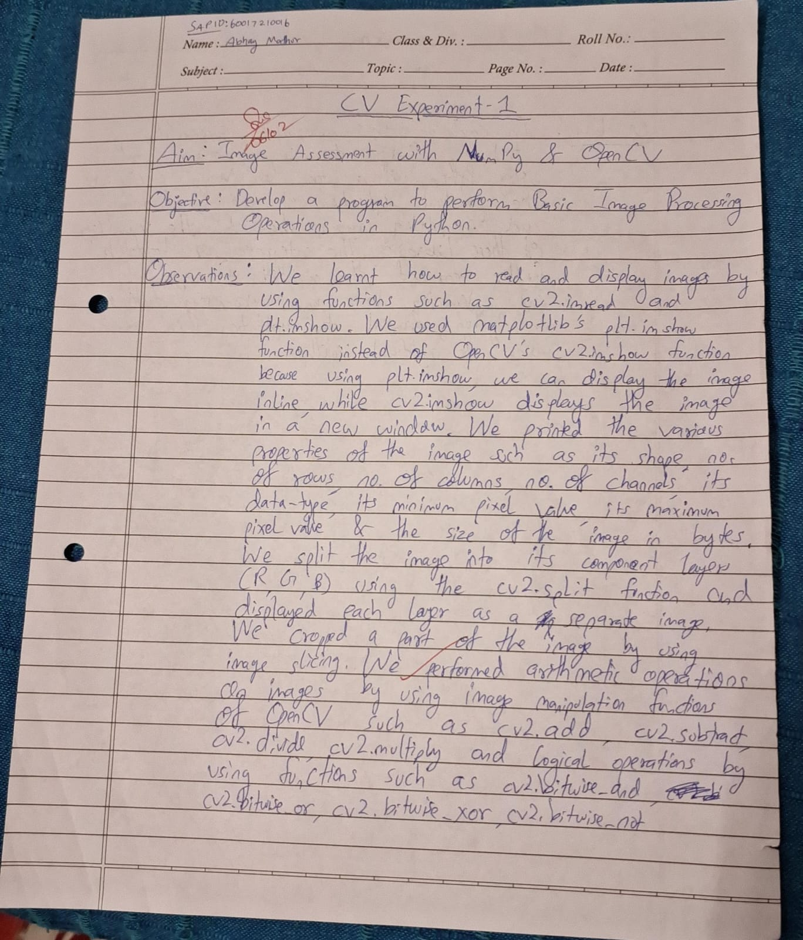

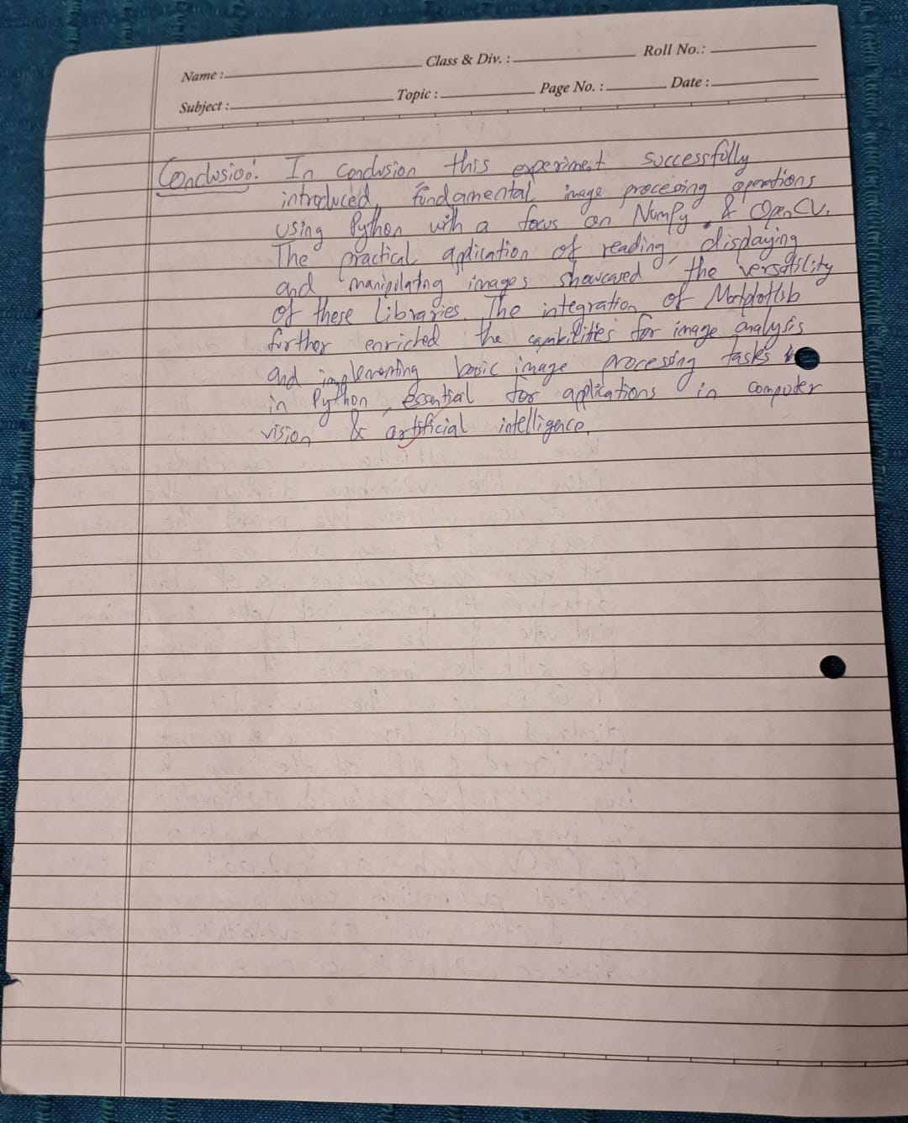

**Conclusion:**

In conclusion, this experiment successfully introduced fundamental image processing operations using Python with a focus on NumPy and OpenCV. The practical application of reading, displaying, and manipulating images showcased the versatility of these libraries. The integration of Matplotlib further enriched the capabilities for image analysis and visualization. Overall, the experiment provided a solid foundation for understanding and implementing basic image processing tasks in Python, essential for applications in computer vision and artificial intelligence.